BUSI 652 – Assignment 1 (ABT Design)

Name: AMAN BHATIA (2338152)
Institution Affiliation: UNIVERSITY CANADA WEST
Course: BUSI 652 PREDICTIVE ANALYTICS
Instructor: DR. MUHAMMAD HAMZA ASAD
Date: 22 FEB 2025

Part I: Converting a Business Problem into an Analytics Problem

Business Problem:
The media company's digital content (e.g., videos, articles) is not engaging users effectively, leading to low viewership and ad revenue

1. Identifying the Business Problem
Low viewership and low ad revenue are caused by the media company's digital content (videos, articles) not engaging users effectively. The lack of engagement will directly impact company monetization efforts since ad revenue is generated based on the impressions and the interaction with the content (Aydin et al., 2021). Moreover, competitors that employ data-driven approaches have become more effective than the company in attracting digital engagement and market reach.

2. Defining the Goal to Address the Business Problem
The impetus is to enrich viewership and boost ad income by enhancing viewer engagement with digital content through predictive analytics. In this, content patterns are identified regarding content that engages and strategies that use data-driven fundamentals to optimize the content according to preference and interest (Dwivedi et al., 2021).

3. Current Efforts to Address the Problem
The company uses generic content strategies, e.g., keyword optimization, publishing content, and social media promotions. However, these are not personalized and do not leverage data analytics and predict user engagement, as per Lopes & Casais (Lopes & Casais, 2022). However, the company still relies on basic metrics (i.e., page views and watch time) and has no idea how the audience interacts with the content.

4. How Predictive Analytics Can Help Solve the Problem
Thus, the predictive analytics can be used to:
- Determine what trends exist in user engagement amongst content characteristics (Munaro et al., 2021).
- Use past user behavior to predict which format is the best to get through to users.
- Find the best timing and platform for publishing content to optimize content delivery (Shahbaznezhad et al., 2022).
- This helps in the form of personalization engines via recommendation engines, bringing more retention and an increased interaction rate (Troise & Camilleri, 2021).

5. Data Availability and Collection Strategy
Currently, the company has access to basic engagement metrics such as:
- Page views
- Click-through rates
- Average watch time
- Bounce rates
- Social media shares and comments
To enhance predictive modelling, additional data can be gathered through the:
- User segmentation (e.g., demographics, location, interests)
- Sentiment analysis from comments and reviews
- Heatmaps and scroll-tracking data
If data gaps exist, data collection can be improved through A/B testing, user surveys, and web tracking tools (Yuniarti et al., 2024)
6. Analytical Base Table (ABT) Design

a. Prediction Subject
Predicting digital content engagement levels based on content attributes and user interactions.

b. Domain Concepts and Sub-Concepts
- Content Characteristics: Length, format (video/article), topic category, sentiment
- User Behavior: Time spent, shares, likes, comments
- Platform Metrics: Source (mobile, desktop), referral channels
- Temporal Aspects: Day of the week, time of posting

c. Useful Features
i. Raw Features
- User location
- Time spent on content
- Type of content (e.g., blog, video, infographic)
- Click-through rate
ii. Derived Features
- Engagement score (normalized combination of likes, comments, and shares)
- Optimal posting time (determined through trend analysis)
- User interest segmentation (clustering based on browsing behaviour)

7. Ethical Considerations in ABT Design
To ensure compliance with anti-discrimination and data protection principles:
- Privacy Compliance: No personally identifiable information (PII) should be used in predictive modelling.
- Bias Mitigation: The algorithm should be tested for potential biases against demographic groups.
- Transparency: Users should be informed about data collection practices and given opt-out options.

8. Descriptive and Target Features in Finalized ABT

Descriptive Features
- Content length
- Format type (video, article, image-based post)
- Number of shares
- User segmentation category
- Platform source (mobile vs. desktop)
- Posting time

Target Feature
- Engagement score (calculated as a weighted sum of shares, likes, and comments)
With predictive analytics in place, the media company will take a structured approach that will help it use predictive analytics to fine-tune its content strategy, increasing user engagement and driving more ad revenue.

Part II - Exploratory Data Analysis and Data Quality Assessment: Food Choices Dataset

1. Introduction
This report is meant to conduct an Exploratory Data Analysis (EDA) on dataset food_coded_data.csv and evaluate data quality problems like Missing Values, Irregular Cardinality, and Outliers. We cannot undertake data analysis without EDA because it helps us understand the underlying structure and patterns within the dataset, find problem areas, and make decisions regarding how to resolve them. Any subsequent data analysis will produce valid and important results only if the data is high quality. The reliability of conclusions may be affected if data quality problems are not appropriately managed. This report will describe the steps taken in performing EDA, such as doing descriptive statistics and visualizations, and how we have identified and fixed data quality issues to clean the dataset.

2. Exploratory Data Analysis (EDA)

2.1 Descriptive Analysis
Key descriptive statistics are first used to help explain the central tendency and spread of the dataset in any exploratory data analysis. This gives us a summary of the data and some information about the general structure of the data. Each variable was calculated for a measurement average, median, and mode.
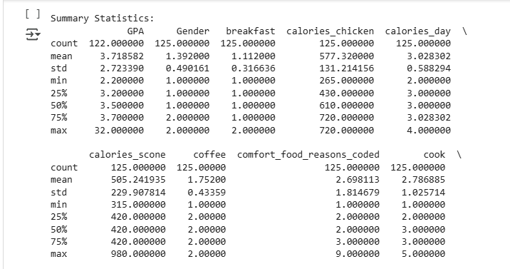
Generally, the mean measures the average value of a variable used to identify the overall level of a particular food choice or demographic characteristic. When the data is skewed, one of the robust measures of central tendency, the median, is very useful as it is the middle value of sorted data. On the contrary, in the same style mode, we see the most frequently occurring value, which enables us to find the most popular food items in the given dataset.
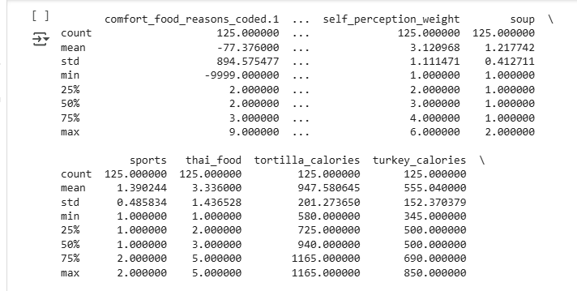
The standard deviation and range were computed to assess data variability. The range gives us the difference between the highest and lowest values in the dataset, and the standard deviation measures the extent of the spread or dispersion of the data points relative to the mean. The quartiles and interquartile range (IQR) were also computed to examine the spread of the middle 50% of the data. The first part of this initial descriptive analysis enabled us to find out for which variables the variability was high and for which it was lower.
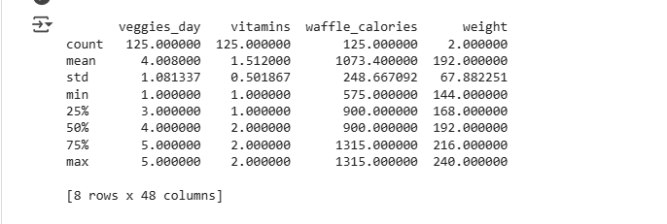

2.2 Visualizations
Visualizations and statistical measures were used to understand the data distribution more clearly. Continuous variables were put into histograms to see how the frequency was distributed.
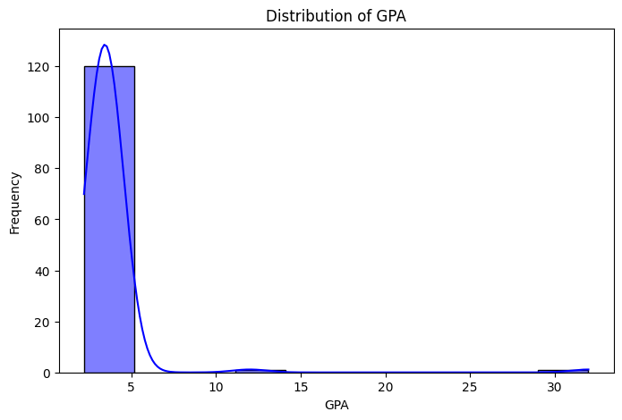
These histograms were used to verify that the data demonstrated a normal distribution or skewness that may have determined how later analysis should be performed.
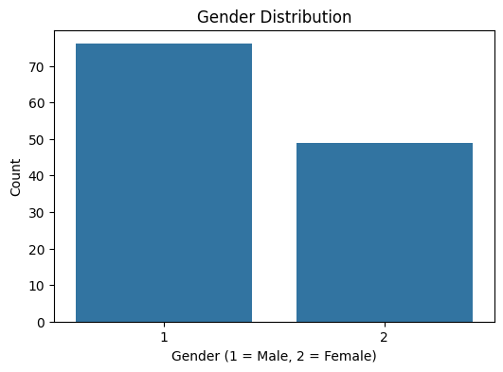
Outliers in the dataset were identified using the boxplots. An outlier is an extreme value that is way different from other observations and could affect the outcome of a statistical test. The spread and quartiles of the data were also gleaned from boxplots.
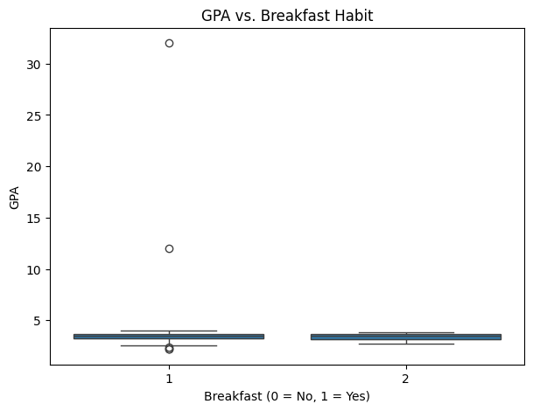
Continuous variables were explored for relationships among each other using scatter plots. Such plots gave us some idea of how food decisions correlated with (or not) demographic variables, e.g., age or income.
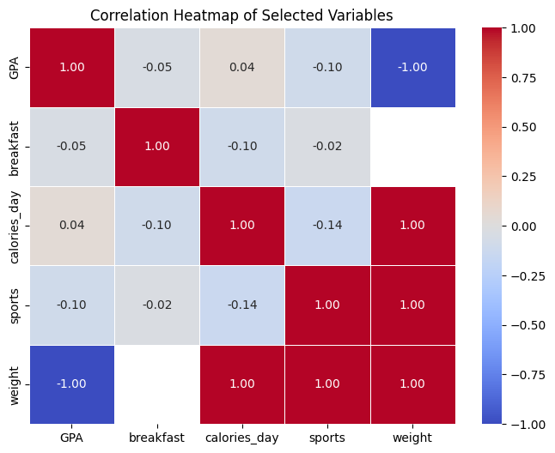
For analyzing categorical variables, they used bar charts and, in some cases, bar charts for food preference types or regional differences in eating food. Descriptive statistics did not provide enough context and could only show that there were year-over-year trends, so the visualizations were instrumental in showing patterns and trends in the data, and they also showed what foods were popular or categories had different trends.

2.3 Data Distribution and Insights
Some key insights about the data behaviour arose from the data distribution, and these were used in the analysis. It also experimented with skewness of the data to see if any variables were heavily deviant from a normal distribution. Nevertheless, several other variables had positive skewed scores, so most of the data values were clustered at the bottom of the scale. On the right, fewer higher values formed a tail. Most of the individuals chose in a similar way, depending on food preferences or demographic factors, but with some exception, individuals had exceptional behaviour.
It was also studied regarding the 'tailedness' of a Kurtosis relation. The higher kurtosis resulting values demonstrate that the empirical data had more extreme values as compared with the others and figure out what is possibly going to be forced on the analysis that was outliers. As with this, we also ran the exploratory data analysis in the dataset. However, we were able to find some trends in the dataset such as there are certain types of food that are used more widely among certain audiences. This finding suggested that further elaborated statistical analyses are needed to test possible preferences.
The EDA in the next section pointed out that missing values, irregular cardinality and outliers’ data issues were faced, which were rectified in the later part. These issues would have serious potential ramifications on the accuracy of any analysis; however, of course, these had to be handled very carefully.
https://colab.research.google.com/drive/1dONggf3b6Ks_kNaWcmLLUnWcCRQ9l_yx?usp=sharing.

3. Data Quality Issues

3.1 Missing Values
The dataset was identified to possess one of the significant data quality issues: missing values. Most of the effects are evident through demographic variables like income or food preferences, which play a significant role in these variables. Reasons for missing data can be non-response or errors in data collection. Several such methods were considered to address this problem. When a small percentage of a variable is missing, it is imputed with the mean or mode of the variable. Because of its widespread use, many imputations are performed to fill in missing values based on the available data so that there will be as little missing variable data as possible. For instance, in cases where there was no income for several respondents, the median income of all of those respondents was used instead.
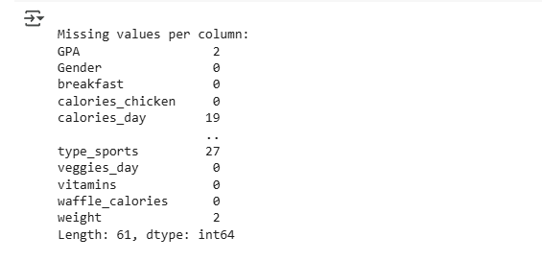
Nevertheless, deletion was used whenever a high extent of missing values was present (more than 30% of a variable). To mitigate circumstances in which Mel's data has too much missing data to warrant including in the analysis, we delete rows with many missing data. Similarly, rows with missing values in key variables for which imputation was impossible or would introduce bias were also deleted. The remaining dataset has been made reliable and represented well by this approach.

3.2 Outliers
The dataset also showed a massive problem with outliers. However, if not well managed, these extreme values can have an excessive impact on resulting statistical analyses. Continued variable outliers were found using boxplots. In some cases, these outliers were valid but rare, such as respondents who purchased food in much more significant quantities than the norm. It retained these outliers since they did not seem like data errors but represented some actual extreme behavior.
In some cases, outliers were considered problematic and were treated linearly by them, for example, by a winsorization. Winsorization replaces extreme values with the closest valid value within a guaranteed range. It helps prevent the influence of extreme values and throws away some data, but not valuable data. Indeed, removal was needed for a few extreme outliers, especially if the values did not seem to be errors or irrelevant to the analysis.

3.3 Unresolved Data Quality Issues
Even with the increasing quality of data, some problems were not resolved. Data duplication, one of the things that could not be fully addressed to their rescue, was one of them. Some duplicates were found and removed, but no good could be said of the leftovers since some shifty duplicates evaded our clutches. These duplicates are not the ultimate reason for the results; however, if they are not removed in a future step, it might affect the results.
The second problem was due to categorical variables, which had a lower or partial frequency of categories. However, some food items were mentioned only a few times, and their consolidation into broader categories may cause them to forget some precise details. The data in these categories may need further analysis and refinement to be handled effectively.

4. Discussion
Exploratory data analysis was done by analyzing the structure and quality of the data using data from the food_coded_data.csv dataset. Descriptive statistics and graphs with implied trends or patterns helped us feel the problems, such as skewed distribution or outliers in food choices. Additional issues with data such as hair, major and minor outliers, and irregular cardinality were identified along with value, and they were taken care of by applying techniques such as imputation, standardization, transformation, etc.
Nevertheless, some challenges remained regarding the duplication of data and categories at low frequencies. Furthermore, this uncleaned data still has these unresolved issues, which signifies that some extra data cleaning steps need to be performed to clean this dataset for more sophisticated analysis, such as predictive modelling or hypothesis testing. On that note, the EDA was an important part of data cleaning and quality checks, which would be a prerequisite for data analysis to give a reliable and accurate result.

5. Conclusion
For instance, in this report, among others, we report an exploratory data analysis of the food_coded_data.csv dataset to describe some main descriptive statistics, visualizations, and data quality problems. Included in the analysis is the necessity to have outliers, missing values, and irregular cardinality on the dataset to pass the checks and ensure that the dataset is fit and reliable for further analysis. Data duplication and low-frequency categories still exist, though many data quality problems have been fixed. Then, issues should be addressed more, advanced imputation methods should be applied, more elaborate statistical analysis should be conducted on the dataset and so on.
Since these practices give the footing to accurate and meaningful insights, they are important exact practices for data cleaning. Therefore, since such demographic factors shape food choices, a causal analysis of relationships within the dataset and food choices could be further pursued using the dataset. Regression analysis or even more sophisticated machine learning can realize such a thing.

References
Aydin, G., Uray, N., & Silahtaroglu, G. (2021). How to Engage Consumers through Effective Social Media Use—Guidelines for Consumer Goods Companies from an Emerging Market. Journal of Theoretical and Applied Electronic Commerce Research, 16(4), 768–790. MDPI. https://www.mdpi.com/0718-1876/16/4/44
Dwivedi, Y. K., Ismagilova, E., Hughes, D. L., & Carlson, J. (2021). Setting the future of digital and social media marketing research: Perspectives and research propositions. International Journal of Information Management, 59(1), 1–37. Sciencedirect. https://doi.org/10.1016/j.ijinfomgt.2020.102168
Gavilanes, J. M., Flatten, T. C., & Brettel, M. (2018). Content Strategies for Digital Consumer Engagement in Social Networks: Why Advertising Is an Antecedent of Engagement. Journal of Advertising, 47(1), 4–23. https://doi.org/10.1080/00913367.2017.1405751
Lopes, A., & Casais, B. (2022). Digital Content Marketing: Conceptual Review and Recommendations for Practitioners. https://www.researchgate.net/profile/Beatriz-Casais/publication/357746605_Digital_Content_Marketing_Conceptual_Review_and_Recommendations_for_Practitioners/links/61dd81d7034dda1b9eeda0be/Digital-Content-Marketing-Conceptual-Review-and-Recommendations-for-Practitioners.pdf
Munaro, A. C., Barcelos, R., Francisco Maffezzolli, E. C., Rodrigues, J. P., & Paraiso, E. (2021). To engage or not engage? The features of video content on YouTube affecting digital consumer engagement. Journal of Consumer Behaviour, 20(5). https://doi.org/10.1002/cb.1939
Shahbaznezhad, H., Dolan, R., & Rashidirad, M. (2022). The Role of Social Media Content Format and Platform in Users’ Engagement Behavior. Journal of Interactive Marketing, 53(1), 47–65. SagePub. https://journals.sagepub.com/doi/abs/10.1016/j.intmar.2020.05.001
Troise, C., & Camilleri, M. A. (2021). The Use of Digital Media for Marketing, CSR Communication and Stakeholder Engagement. Strategic Corporate Communication in the Digital Age, 161–174. https://doi.org/10.1108/978-1-80071-264-520211010
Yuniarti, Y., Aziz, M., & Gani, H. A. (2024). The Impact of Creative Content on Digital Marketing Effectiveness: A Comprehensive Analysis. International Journal of Scientific Research and Management, 12(03), 6179–6193. https://doi.org/10.18535/ijsrm/v12i03.em19

